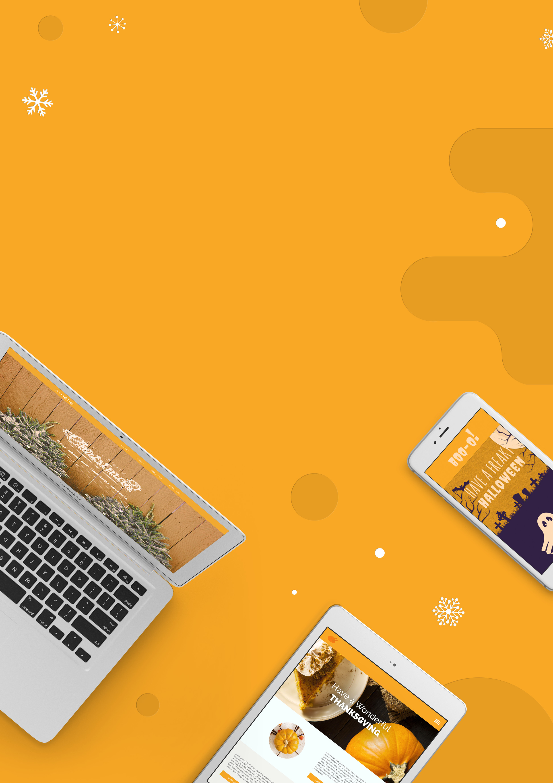
Preparing Your Website
for the Holidays is Just Like
Planning a Party

2015

6 Ways

www.yoursite.com
Your Logo

Table of Contents

Introduction 03
Sending Out Invitations 04
Getting Your House in Order 08
Laying Out the Appetizers 13
The Three-Course Dinner 15
Making Your Visitors Feel Welcome 16
Hiring a Party Planner 18

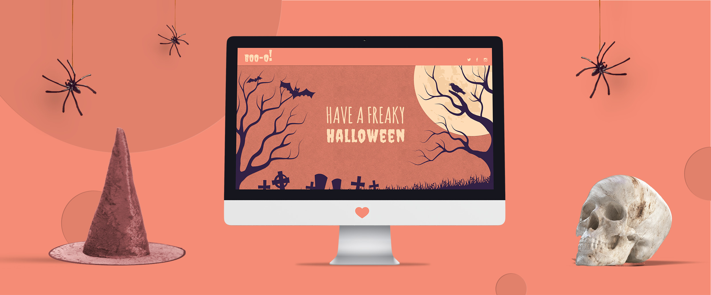

Introduction

Right around Halloween there’s an interesting thing that happens in malls and on main streets across America. Somehow oddly intermixed with the pumpkin, witch and spider decorations that adorn every store you walk passed, you’ll begin to see a smattering of what looks like Christmas lights and signs that read “Holiday Sale: 20% Off.”

Yes, it may still be the biggest shopping day of the, but the truth is nobody waits for Black Friday anymore. And there’s a reason for that.

The holiday season is easily the busiest time of year, and business owners (just like you) need to do everything they can to stay ahead of the holiday rush and beat their competition to the punch. This means loading up on inventory, staffing up, staying open late, and hammering out an effective sales and marketing strategy. It’s this last part that can be the trickiest and most critical. After all, if nobody knows about your store, products / services, and promotions, all the rest of this work could be for naught.

Possibly the most critical tool you have in your marketing arsenal is your business’ website. It is the central location for your business online and often the first place potential customers will interact with you. This means you need to make sure your website is in top-notch shape for the holidays — and here is how to do it.

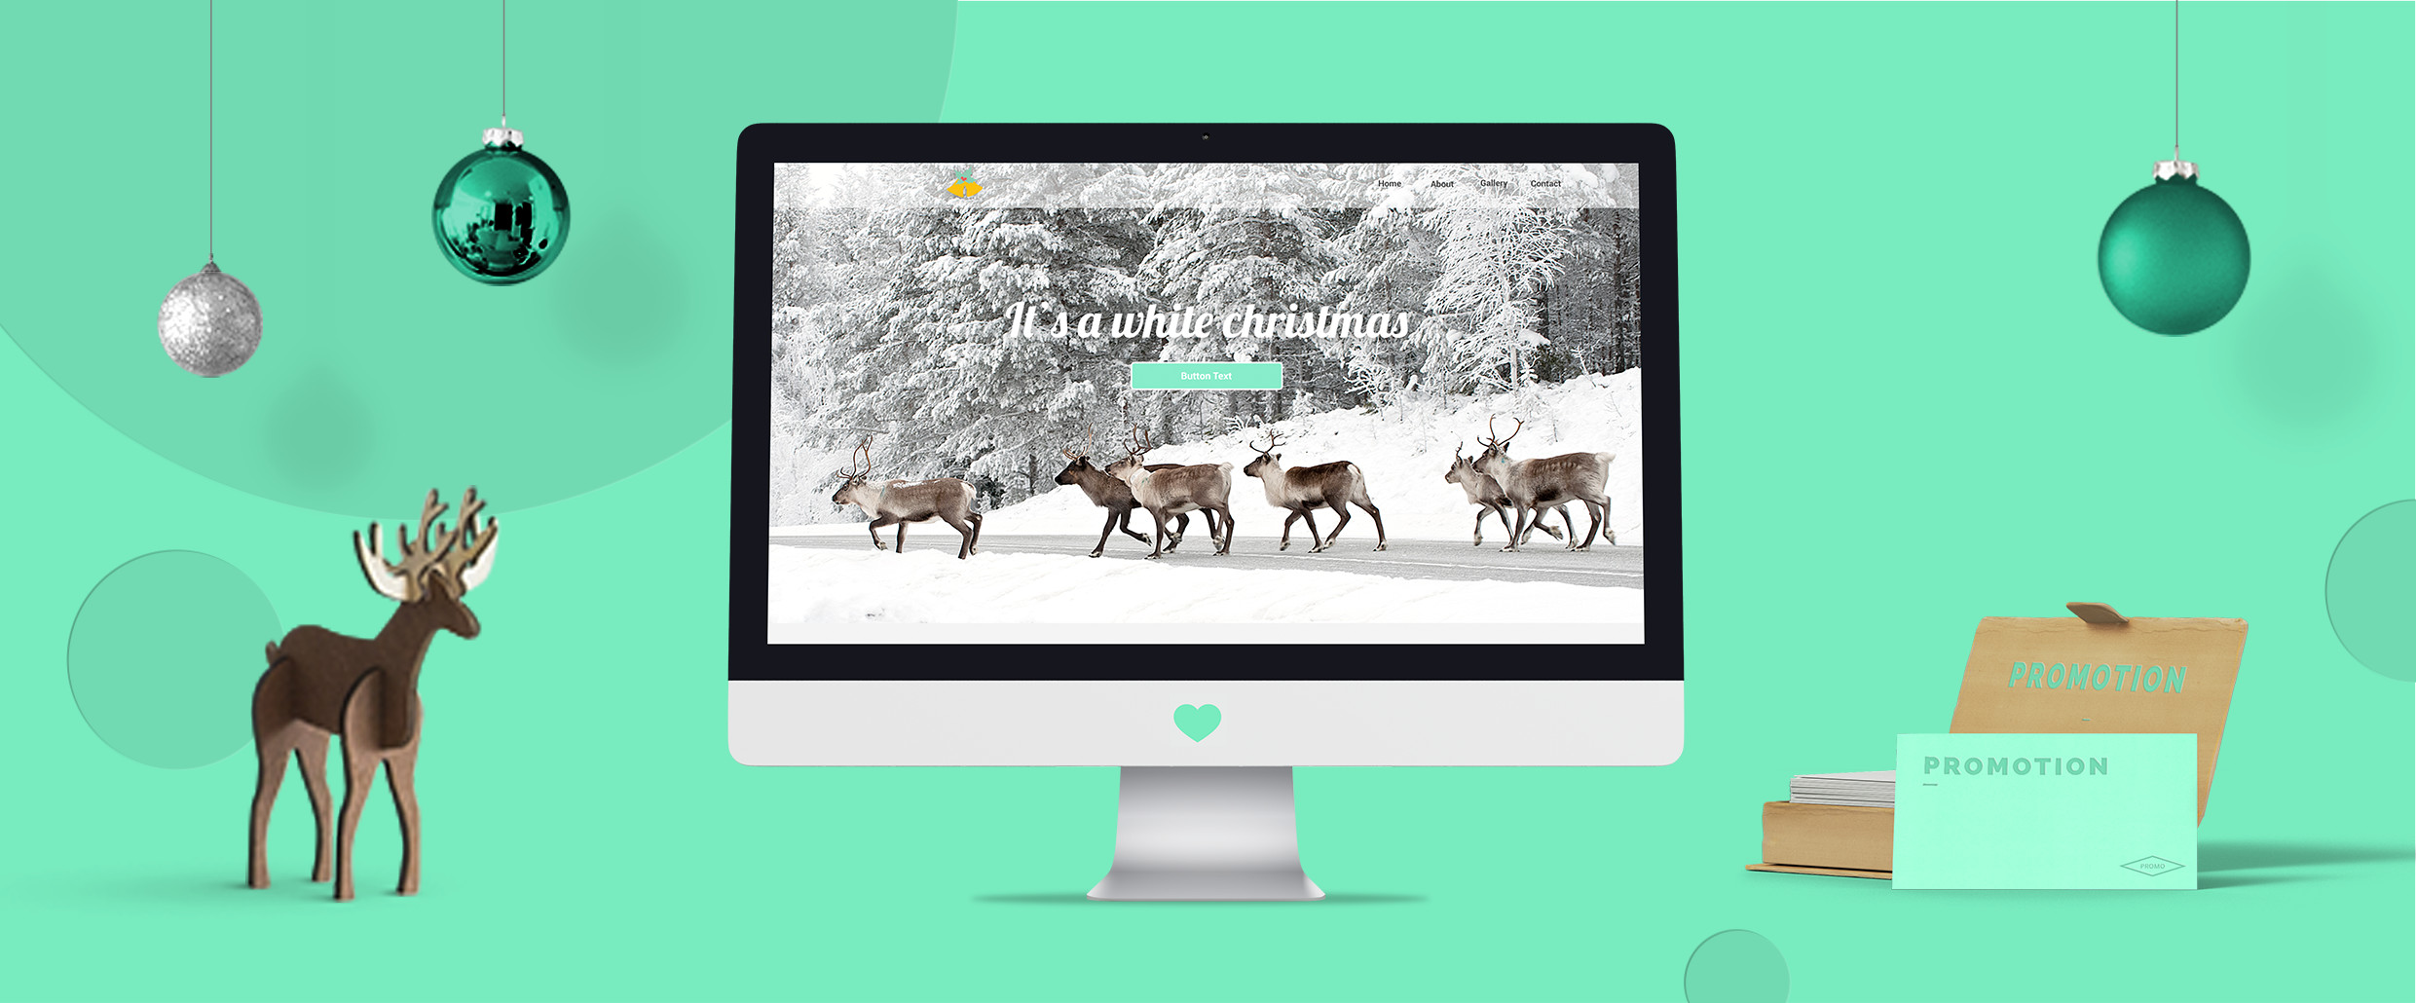

Sending Out Invitations

How and When to Tell Your Customers About Promotions

Communication is key during the seasonal of selling, and there are a variety of means at your disposal for reaching out to your customers. You may be familiar with some, but there are many you may not be aware of, yet. One such communication tool is push notifications.

Push notifications have long been lauded by app publishers as one of the best ways to communicate with people (Do you have an app for ESPN? Push notifications are those messages you get on your phone that let you know the Red Sox are winning). However, Google recently enabled them for the web via its browser, Chrome.

For a person to receive push notifications, all they need to do is opt-in on your website and then have Chrome running on their computer or phone. You can then send short messages — it’s best not to write the entirety of War and Peace in a push notification — to your customers to let them know about any special holiday promotions you’re running.

It’s important to note that you’ll want to enable this feature on your site as far in front of the holiday season as possible. Much like with an email or newsletter list, the more people you have subscribe to your push notifications the better. A large following is key to boosting yuletide engagement. And when used properly, push notifications can get a whole lot of engagement.

A study by PushCrew yielded some astonishing results when it came to push notifications:

“The opt-in and click rates are amazing! Some…have seen an opt-in rate of 40% (10X the rate at which an average email list builds, and 20X the rate at which an average Twitter list populates) and a click rate of 20%.”

Tip: Push notifications make a great tool for communicating with your customers, but you can over do it. Be careful not to send out too many in a short amount of time, or your customers may start to ignore your messages.

And speaking of email marketing strategy, this is should be another vital part of your marketing during the holidays. Though not as new and revolutionary as push notifications, email marketing is an effective tool for reaching out to your customers to highlight special offers and let them know about what’s going on with your business.

One of the best parts of email marketing is that, unlike with push notifications, character and word counts are less of an issue. Once again, you don’t want your message to be too long, but you can communicate a lot more ideas and direct your customers to a lot more places on your website.

Here are a few big things you should keep in mind when preparing holiday email blasts to your customers:

- Subject Lines — Try to keep your subject line short and interesting. Your email is no good if your customers don’t open it, and a long, boring subject line will get a one-way trip to the trash folder.

- Body — Relevance is the most important thing in the body text of your email. Extra information is just that — extra. It isn’t needed and your reader’s attention span is pretty short. So try to keep it brief, while also maintaining a personal and friendly tone. People like that kind of thing.

- CTAs — CTA stands for call-to-action. This is the thing you want your reader to do. Often times you see these in the form of a button or link at the bottom of an email. Though you can give someone an offline CTA (e.g. Visit Our Store Today!), it’s a better idea to give them something to do right in that very minute (e.g. See Our Holiday Specials). Sending people to your website, blog or a landing page goes a long way towards boosting customer engagement.

Both push notifications and email marketing are largely one-way communication tools. Your customers have signed up to receives messages from you, but there isn’t really a way for them to reach back out This is why it’s and blog, especially around the holidays. Everyone is getting online to share pictures of family get-togethers and connect with
far-flung friends across the world. So it kind of goes without saying that Facebook is a place you want to be.
Nobody is saying you need to be commenting on the photos of people who have liked your business’ page, but you should be posting regularly to remind people you’re around.

In addition to plain text status updates, it’s also a good idea to post content that people will want to share. Infographics, interesting articles or videos from around the web, and links to your blog are all good ideas, but probably the most valuable is your blog.

Why? First, a blog is great for SEO. Google loves original content and a blog provides you with the opportunity to write as much as you need, while also working in those all-valuable keywords. Second, it’s very good way to start a conversation with your customers about relevant holiday topics. For example, if you run a bar and restaurant, a good blog topic would be “5 Christmas Drinks You Need to Try Before New Year’s.” Not only is this likely to get shared around on social media, but there’s a good chance you’ll be able to speak directly with your customers via the comments.

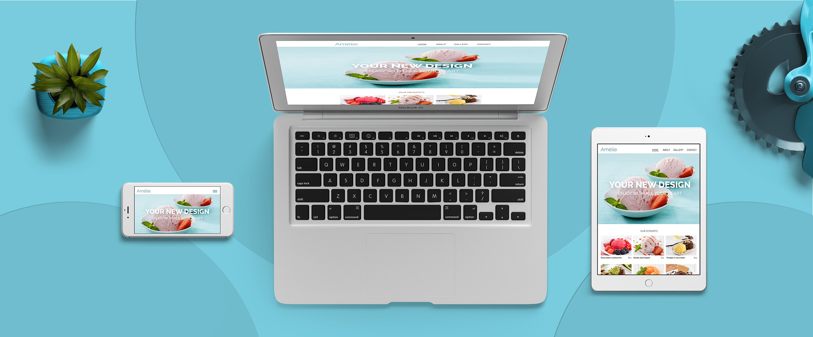

Getting Your House in Order

The Basics of a Good-Looking, Functional Website

Once you’ve figured out your strategy for reaching out to your customers, the next step is to get your website in order. Even if you think your website is in great shape, it never hurts to go back and do a little spot-checking. And the most obvious area to start with is the is your overall website design.

When looking at your site’s design, it’s a good idea to remember the rule, “less is more.” It’s easy to overload your visitors with information, images and flashy animations. All of these used in the correct way are fantastic. They bring life and personality to your site, but you need to make sure the visitor can find what they’re looking for.

Here are a few things to keep in mind:

- Use Flat Design — Flat design has a lot to do with color. Simple and prominent primary colors, laid out in an uncomplicated way, will give your site a sleek look that won’t overwhelm your visitors.

- Prominent CTA — Try to keep your call-to-action high enough on your site that when anybody gets there, it will be one of the first things they’ll see. Once again, this is the number one action you want your visitors to take. Whether that’s to call your business, stop by the store, reserve a table or place an order, don’t make your potential customers search for it.

- Header and Navigation — Often overlooked, your header and navigation are a very important part of your site. Keeping with the idea that simple is best, structure your navigation so that your most prominent pages are visible right away, and all other pages are structured underneath them. This secondary navigation is called the “sub-navigation.” The rest of your header should maintain some very basic information (think your phone number or business’ address) and possibly a small logo.

- Footer — Your footer is a lot like your header, except at the bottom of the page and you can put some more information in there. It’s okay to go a little more text heavy with this part, but it would be unwise to start loading it up with images.

After you’ve decided your happy with your site’s layout, it’s time to pick your images and write your text.

The most important thing to remember about images is they need to be relevant to your business. Are you an accountant? If so, a giant image of the sun rising over the Grand Canyon may not be for you. Instead select a nice image of yourself, or even better an image of you interacting with clients. This will give a positive feeling to the viewer and immediately help to build trust. Remember, a picture is worth a thousand words, so take your time when choosing what images will represent your business to the world. However, it’s important to remember that turning your site into a pure picture book is probably not the best way to go. At some point, you’re going to need to sprinkle some actual text in there too.

If you’re nervous about writing text for your website, don’t be. You don’t have to be a playwright, you just need to ensure that you can communicate clearly, warmly and effectively. Say what you need to — no more, no less.

For example, if you owned an air conditioning repair company in Austin, Texas, you may right a tagline (generally the main text that goes over your site’s header image) for you website that says:

“Keeping Austin Cool Since 1985.”

This tagline is short, memorable, speaks to what your business does and builds trust with the audience — all of the things you strive to accomplish with your writing.

And after you’ve written everything you think your site needs, feel free to ask someone else to review your text. Everybody needs an editor.

At this point in the process, you may love how your site looks...on a desktop. But what about how it works on a smartphone or tablet?

In an age when people are completely inseparable from their mobile devices, ensuring they receive a good experience no matter what they’re using to view your site is critical. To become mobile-friendly, you essentially have two options.

- Create a Mobile-Only Website — If you have an existing desktop website, you can quickly and easily create its mobile counterpart. These sites generally have a URL that reads “m.examplesite.com,” and are basically just your normal website reformatted for the small screen.

- Create a Responsive Website — A responsive website is one site that works perfectly on desktop, tablet and mobile. It will automatically reformat itself to deliver an optimal visitor experience, no matter what kind of device your site visitor is using. This is now the preferred choice of most web designers and small business owners, as it future-proofs your website for whatever kind of devices will hit the market down the road.

Besides visitor experience, there are a variety of other reasons why you would want to be mobile-friendly.

First, it lowers the bounce rate, which makes perfect sense. Your bounce rate is the percentage of people who land on your site and immediately abandon it. If a visitor clicks on a link and is taken to a site where they have to pinch and zoom to find what they’re looking for, they’re probably going to move on very quickly. Mobile visitors have notoriously low patience for non-optimized websites.

Second, it improves conversion and engagement. Big, thumb-friendly buttons that allow your visitor to call your business or get directions to your store in just one click are essential for driving customer action.

Third, Google wants you to be mobile-friendly, and if you aren’t there could be consequences. Recently the search engine giant declared that mobile-friendliness is now a ranking factor. This means if you aren’t up to Google’s mobile-friendly standards, you could lose your coveted spot in their smartphone search results. It’s important to note that both mobile-only and responsive websites, will work perfectly in this post-Mobilegeddon world and keep you in Google’s good graces.

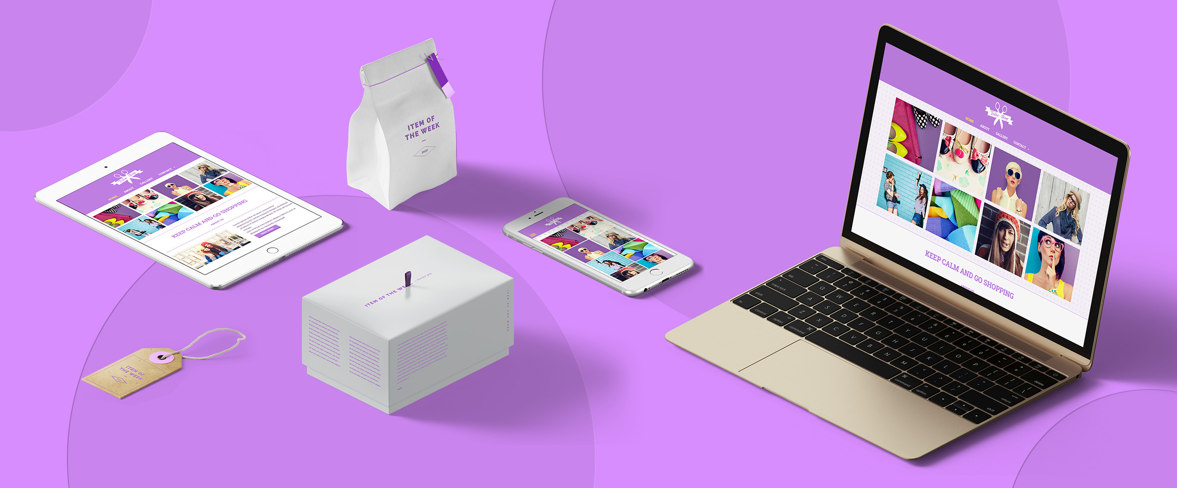

Laying Out the Appetizers

Placing Your Most Popular Products
on Your Site

The space on the homepage of your website is not limitless. There is a finite amount of real estate that you can leverage. Like all real estate, this makes it valuable, and to maximize holiday sales you’ll want to use it to display your flagship offer.

If you have a special product or service that goes along with the holiday season, this is the perfect thing to highlight. If you don’t have a specific yuletide-related product, simply use this space to show off your most popular offer.

Tip: Use your flagship offering as your header image with a couple of quick bullets, and a link to learn more about it on another page.

If you can’t think of a lead product to promote, the top of your homepage can, and should, be used to advertise special holiday deals, particularly leading up to and during Black Friday weekend. It’s important to carefully plan out any specials you’re going to be providing during the holidays far in advance. There are a variety of layouts for you to play with and it’s a good idea to take some time to find a design that works for your site. You can also use website personalization tools, inSite, to schedule your holiday deals to automatically appear throughout the season, but we’ll get into that more in a minute.

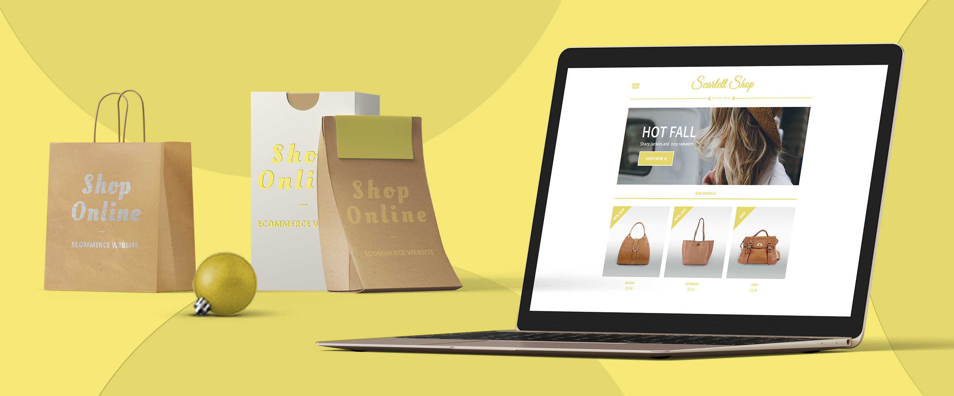

The Three-Course Dinner

Using eCommerce to Make the Most Sales

If you’ve been running a traditional brick-and-mortar business, you may want to consider expanding into eCommerce. It may seem surprising, but a growing number of small businesses consider the ability to sell online important to their business. According to recent research, nearly one in five SMBs believe eCommerce is an important part of driving sales.

There are a variety of options when it comes to eCommerce. A basic ten-product store is available; however, you can create either a 100-product or 1,000-product store. These are highly valuable, as they also include certain advanced features, such as additional shipping options and discount coupons.

It is important to keep in mind than setting up an eCommerce store actually has big implications for your day-to-day offline operations. You will need to figure out shipping, maintaining your inventory and may even need to look into setting up new payment options.
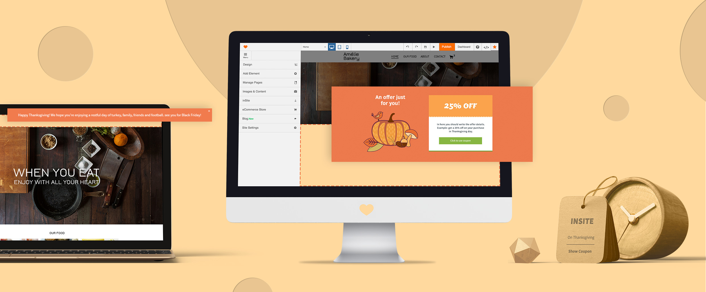

Making Your
Visitors Feel Welcome

Creating Personalized Website Experiences

Adorning a home or store with a cornucopia around Thanksgiving or some tinsel for Christmas, is a time-honored tradition. But what about your digital storefront? Doesn’t that deserve to be made a little more festive too? Well, inSite is the perfect tool for making that happen.

There are a variety of special effects that you can easily add to your website in just a few clicks, like December snow or fireworks for New Year’s. Simply schedule them to display when you want to add a little bit of extra surprise and delight to your visitors’ website experience. But there’s more to inSite than just adding some festive flare.

Website personalization tools, are fast becoming a marketer’s best friend. By changing the content of your website based on triggers such as time, visitor location, number of previous visits, and more, you can create a hyper- relevant experience for site visitors.
It should come as no surprise that the more relevant and personalized an experience, the more likely a visitor is to become a customer. Everybody loves a personal touch.

Here are a few key stats you should know about website personalization:

- Businesses that leverage personalized content on their website average a 19 percent increase in sales (Econsultancy 2013)

- Personalized CTAs resulted in a 42 percent higher conversion rate than generic CTAs (HubSpot 2013)

- 94 percent of in-house marketers agree that website personalization is critical to current and future success (Econsultancy 2013)

inSite is an incredibly flexible tool, so really the only limit on what you can do with the various triggers and actions is your own imagination.

Would a welcome video for first-time visitors with a happy holidays message help you connect with customers? What about scheduling different promotions to run on the site throughout Black Friday Weekend? If you want to run a special campaign for the holidays, you can use the Campaign URL trigger to display content on your website that directly reflects what you’re trying to promote.

No matter what you come up with, inSite makes an outstanding way to promote special offers and deliver an unparalleled website experience.

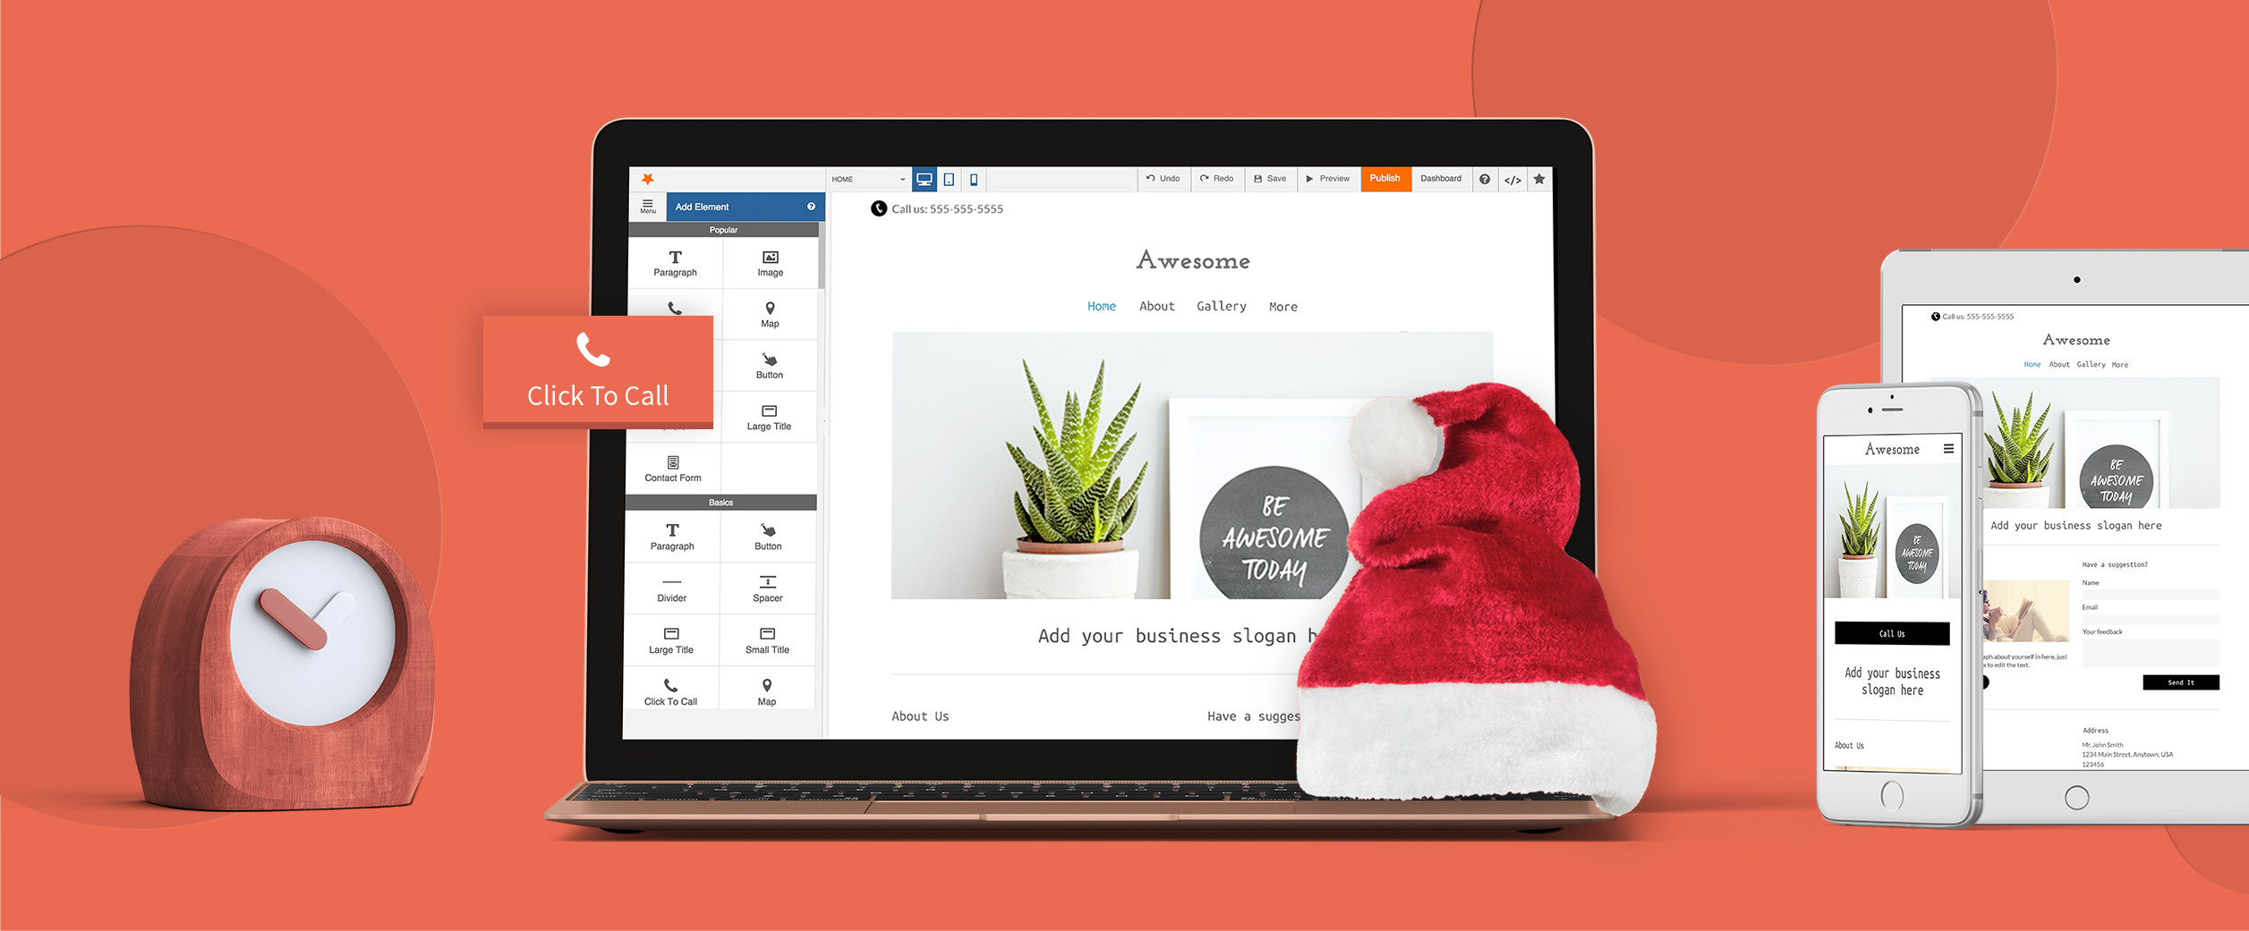

Hiring a Party Planner

Getting Professional Help for Your Website

Since you only have a set amount of time to get everything ready for the holiday rush, or of think you could benefit from some professional guidance, you may want to consider hiring a bit of help. This can be for building actual websites from scratch, implementing advanced features, or running a variety of advertising campaigns. No matter what you need help with, hiring another set of hands enables you to spend more time doing what is most important to you: gearing up your brick-and-mortar business to make the most of the holiday rush.
www.yoursite.com
Your Logo

About Your Company

Lorem ipsum dolor sit amet, fugit sententiae efficiendi id sea. His ad fierent ancillae conclusionemque, consul noster appellantur ad mei, no eros putant mentitum Agam eirmod liberavisse pri in, duo no harum maiestatis, te dicit nonumy consequuntur eam. Tacimates efficiantur te vel. No duo stet vitae doming, est tibique ocurreret ex. Suas verterem disputando an usu, eu tota pertinax mei, tale deserunt contentiones eos ex.

Est ea percipit senserit concludaturque, qui ex magna summo. Dicam voluptatibus te sea, vel eligendi urbanitas dissentiunt id, cotidieque consectetuer has in. Vim ad iisque iuvaret eloquentiam. Ad pri vocibus epicuri. Pri nobis doming ne, facer singulis cu vel. Singulis quaestio ex his. Ad qui debet aperiri lobortis, ex reque ornatus lobortis sed.

